## 

**HACETTEPE UNIVERSITY**

**ENGINEERING FACULTY**

**DEPARTMENT OF COMPUTER ENGINEERING**

**BBM 325**

**INTERNSHIP REPORT**

**Ali KAYADİBİ**

**21727432**

**Performed at**

**BEAM Teknoloji**

**Beginning and End dates 22/07/2019 – 9/09/2019**

**Duration in Work Days 30**

**TABLE OF CONTENTS**

**1 Introduction** 2

**2 Company Information** 2

**2.1 About the company** 2

**2.2**  **About your department** 2

**2.3**  **About the hardware and software systems** 2

**3**  **Work Done** 3

**4 Performance and Outcomes** 14

**4.1**  **Applying Knowledge and Skills Learned at Hacettepe**. 14

**4.2**  **Solving Engineering Problems** 14

**4.3**  **Teamwork** 14

**4.5**  **Professional and Ethical Issues** 14

**4.6**  **Impact of Engineering Solutions** 14

**4.7**  **Locating Sources and Self-Learning** 15

**4.8**  **Using New Tools and Technologies** 15

**References** 15

# 

# **1 Introduction**

This summer I have done my internship in BEAM Teknoloji which is a startup company in ODTÜ Teknokent.Company has different deparments such as penetration testing, network, software but the main focus area of the company was on cyber security..I was in software department.The reason why I did choose this company is I was curious about cyber security and I always wanted to learn more about what they do, what tecnologies they use this is why I choosed this company.

I mostly worked with software problems, implementing security methods to protect source codes,worked on my web project.I always wanted to learn how internet works, how websites interfaces with users, how companies protect their websites.

# **2 Company Information**

## **2.1 About the company**

BEAM Teknoloji is a startup compant which is founded in 2011 by the support of Bilim Sanayi ve Teknoloji Bakanlığı.They are located in ODTÜ Teknokent. Their main target is providing security, performance and quality and also acting as a neutral evaluation center. They evaluate the compliance of companies quality and security requirements with the standard of common criteria.They also show support in every step of common criteria.They also provide different solutions for their customers such as source code analysis, penetration and weight testing, compatibility testing etc..

## **2.2 About your department**

Software department had 6 people. They were responsible of website, new features for website.And also they were responsible of code analysis,performance, implementation of security methods in customers code etc.

## **2.3 About the hardware and software systems**

Software department was using AngularJS, PhP, Html, Intelij Java, Thymeleaf, MongoDB, MySQL, Javascript and many more software systems. And they were using Docker as well.

**2.4 About your supervisor**

My supervisor was Emre Çakır.He is living in Ankara.His telephone number is +90533 464 15 68.His email address is [cakiremre@gmail.com](mailto:cakiremre@gmail.com). He is graduated from Bilkent University, Computer Engineering in 2005.

# **3 Work Done**

I have focused on learning the languages,programs that software deparment uses for the first 4 week.During that time, I have red lots of documentations about these languages, watched educational videos.After getting similar with these tecnologies, my supervisor wanted me to develop a web project from stratch.Which includes two different databases, frontend and also backend with the languages that I have learned. That time I was familiar with Java Spring Framework, Javascript, Html, Css, MongoDb, MySQL.So I started my web project and developped a website which is similar to populer hotel searching websites, it has a logging system, searching system, reviewing the hotels and also adding them to customer’s whishlist.I had different functions for searching which searches for given money, given city, given number of reviews...Here is some of my codes from my web project.

Back-End Java / Java Spring Framework Part

This is spring boot application start call.

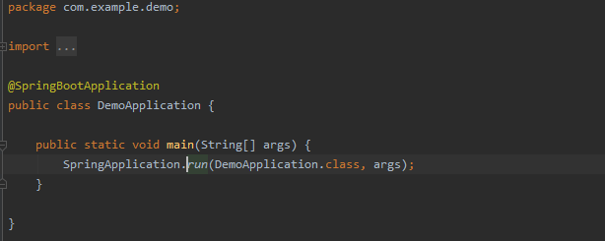

This is hotel controller class which has the functions about hotel objects.

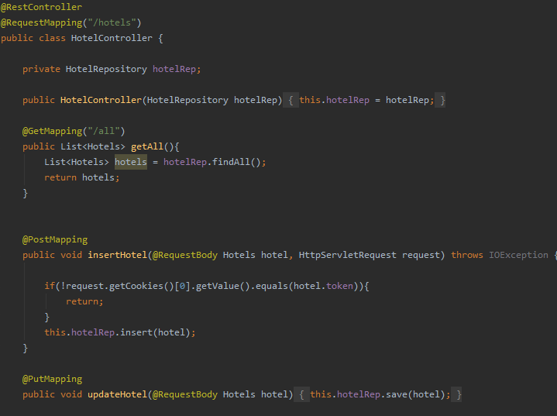

This is my Hotel class which have attributes of Hotels Objects.

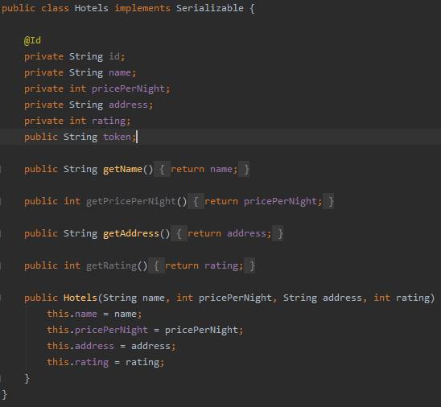

These are my html codes of front page that show inputs for hotels , functions about hotels etc.

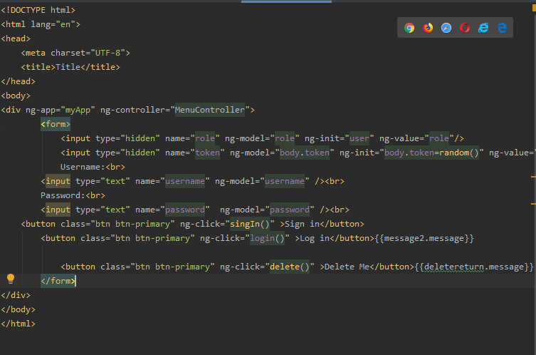

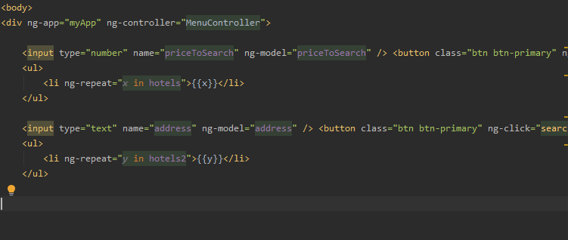

This is where I handle javascript queries by get,post mappings.Each function have it’s own pupose

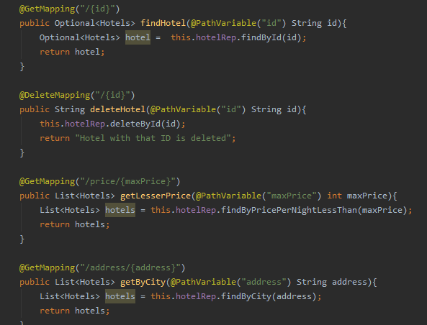

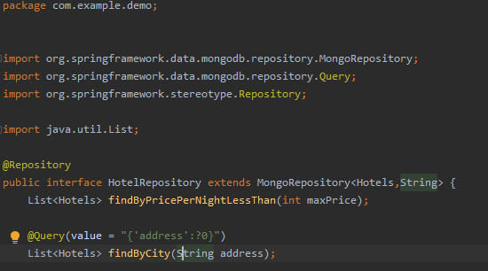

This is my mySQL implementation part.And 2 functions of findByUsername and findByUsername

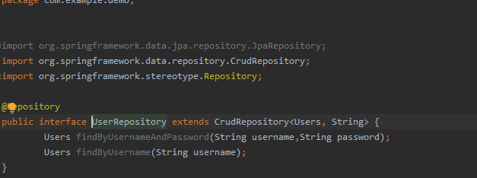

This is main page.

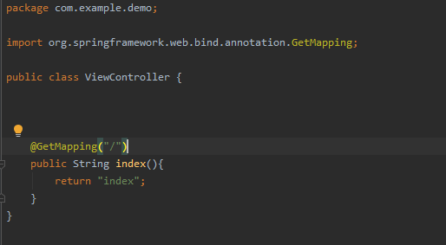

This is javascript where each thing shown in front page is implemented.Each function has different purpose and some sends queries to backend

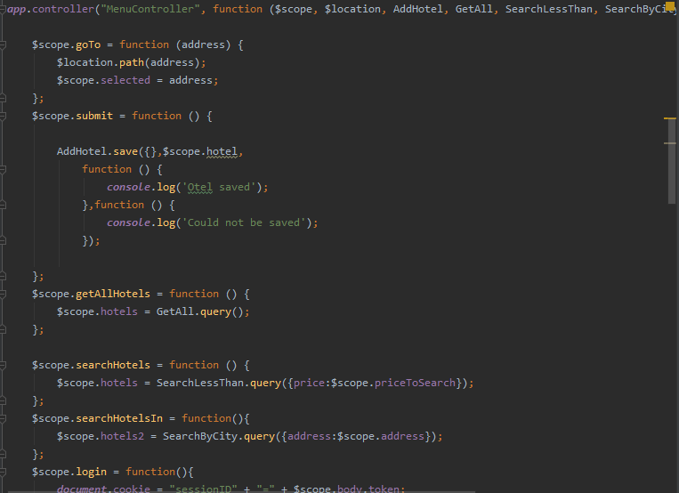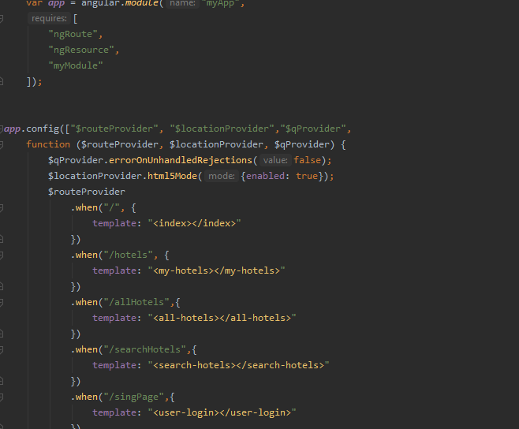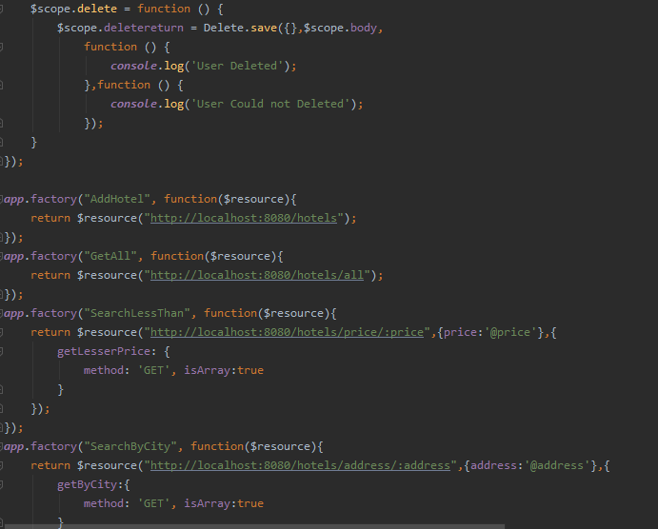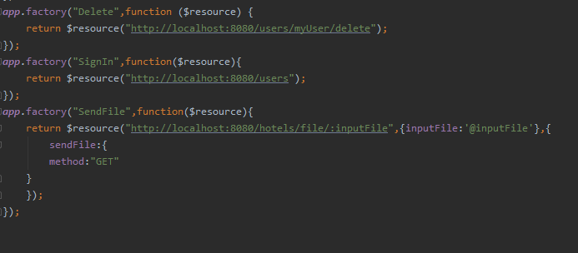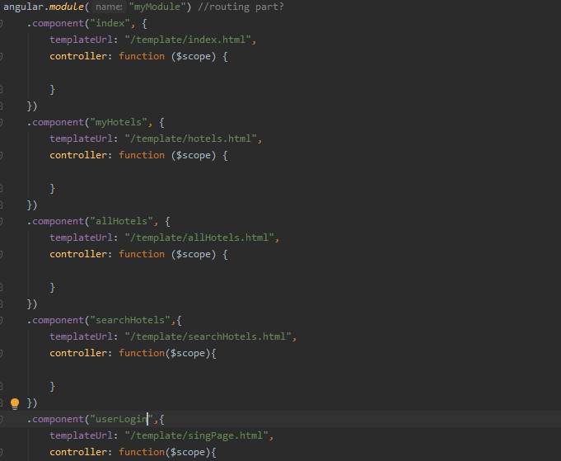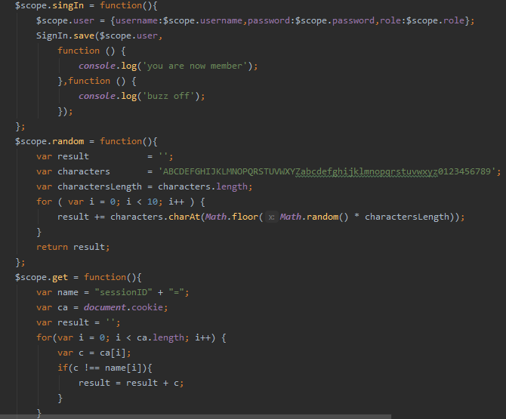

After making a full website later my supervisor wanted me to include top 10 injections from years over time.I have used original documentation of OWASP Top 10 which is a open web project that finds most populer vunreabilities over time.There are some of the most populer vunreabilities that I have implemented on my code.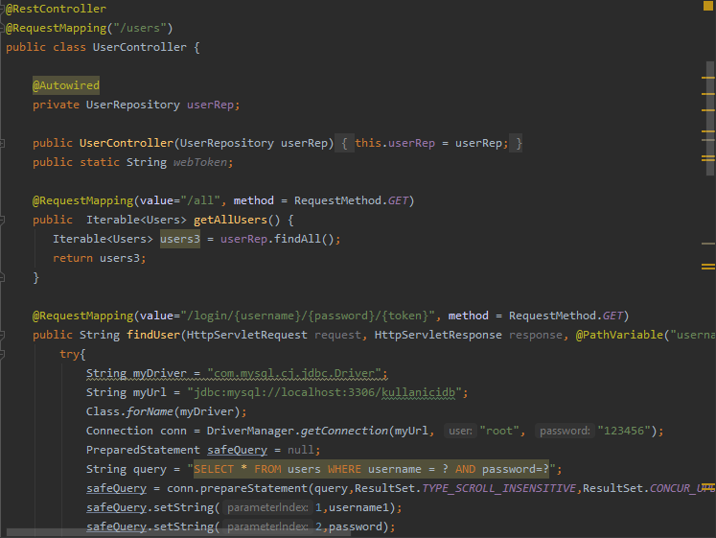

There is a implementation of SQL Injection.Parameterilation solves the issue.

This is where I limit the user’s tries.This is broken authentication, XML Enternal Enteties.

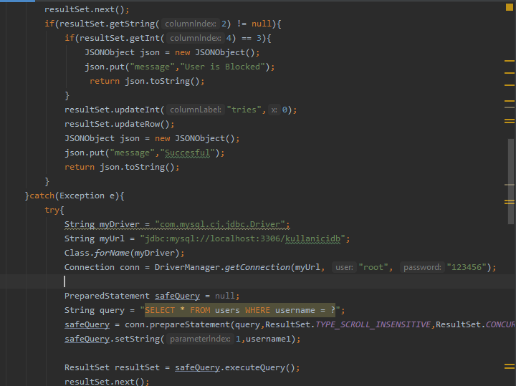

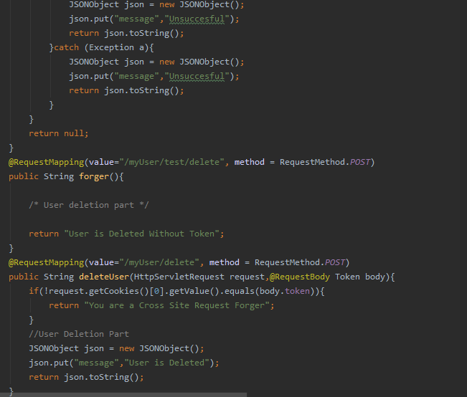

This is where I control Cross site scripting.

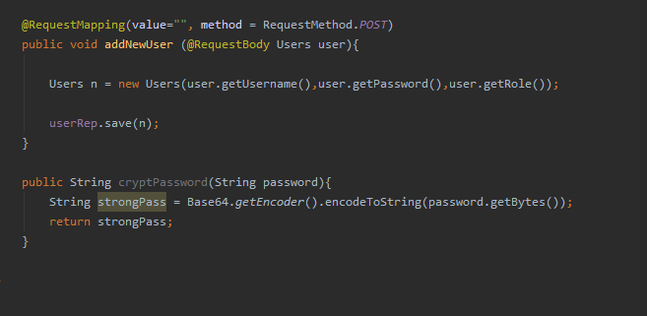

Users class.

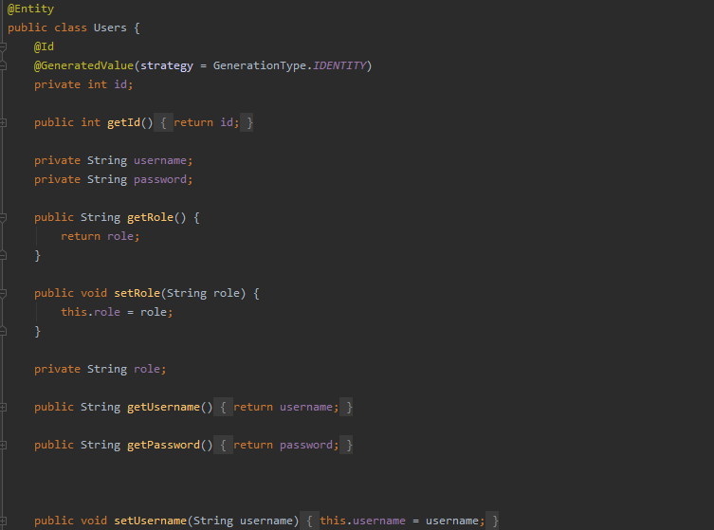

These are my codes from my web project that includes frontend , backend , database, vulnerabilities, injections.

# **4 Performance and Outcomes**

## **4.1 Applying Knowledge and Skills Learned at Hacettepe**.

I mostly used my knowledge in programming languages, my knowledge in data structures, algorithm knowledge.I have easily learned the software programs because I was experienced in Hacettepe.

## **4.2 Solving Engineering Problems**

I have solved page directing, sending queries to back end of the website, implementing owasp top 10 vulnerabilities, organising database, performing queries in database, correcting vulnerabilities in customer source code and much more.

## **4.3 Teamwork**

We had one person who is in charge of software department(also my supervisor).They were all computer engineers from different universities.They were always communicating with each other during implemantation or testing.They were using a program which they select what they want to do, after doing that uploading that to github to share with others.Also they were using slack during working hours.

.

## **4.4 Impact of Engineering Solutions**

Quality, performance is very important, following common criteria is a must, every code has weakness, you must take your job serious because cyber security is a serious business and has lots of effects.

## **4.5 Locating Sources and Self-Learning**

At first my supervisor wanted me to learn MongoDb.I was familiar with self learning so I started learning using original documentation.After than I started learning Java Spring framework because they were using spring in the backend.Later I have learned Thymeleaf, AngularJs, Html, Css. After that I had knowledge about frontend and backed so I started a mini web project.I have used ngResource, routing, single page website, custom functions, filtering functions..Later they wanted me to learn injections.There are top 10 popular injections so I started learning them and after learning they wanted me to implement these to my little web project.

## **4.6 Using New Tools and Technologies**

I have learned Java Spring,MongoDb,MySQL, AngularJs, Thymeleaf, Html, CSS.I am familiar with them.I think I am intermediate with these programs/programming languages.I have watched videos from youtube, read their original documantations.

**5 Conclusions**

I have worked with my web project.I was not familiar with frondend but I am familiar with backend because we have seen Java in Hacettepe.I have developped full website and worked with injections..Algorithm and data structures knowledge is important in this part.I couldn’t worked more because learning took too much time.

# **References**

1. <http://websystique.com/angularjs/angularjs-crud-application-using-ngresource/>
2. <https://docs.angularjs.org/api>
3. <https://docs.mongodb.com>
4. <https://medium.com/@mustafakoroglu/spring-boot-ile-web-sayfaları-thymeleaf-9613c8a6e888>
5. <https://spring.io/docs>
6. <https://www.freecodecamp.org/news/learn-mongodb-a4ce205e7739/>
7. <https://www.owasp.org/index.php/Category:OWASP_Top_Ten_Project>
8. <https://www.w3schools.com/tags/tag_doctype.asp>